**IMPLEMENTING SORTING AND SEARCHING**

IDENTIFICATION DIVISION.

PROGRAM-ID. sortt.

ENVIRONMENT DIVISION.

CONFIGURATION SECTION.

INPUT-OUTPUT SECTION.

DATA DIVISION.

FILE SECTION.

WORKING-STORAGE SECTION.

01 ARRAY.

02 A PIC X(10) OCCURS 20 TIMES.

77 N PIC 9(15).

01 T PIC X(25).

77 I PIC 9(2).

77 J PIC 9(2).

01 P PIC X(5).

77 S PIC X(15).

*-----------------------

PROCEDURE DIVISION.

MAIN-PROCEDURE.

DISPLAY "ENTER THE SIZE OF THE ARRAY".

ACCEPT N.

MOVE N TO P

DISPLAY "ENTER THE STRINGS".

PERFORM A-PARA VARYING I FROM 1 BY 1 UNTIL I>N

PERFORM X-PARA VARYING I FROM 1 BY 1 UNTIL I>N

DISPLAY "SORTING LISTS ARE".

PERFORM S-PARA VARYING I FROM 1 BY 1 UNTIL I>N

DISPLAY "SEARCHING ELEMENT".

ACCEPT S.

PERFORM E-PARA VARYING I FROM 1 BY 1 UNTIL I>N

DISPLAY "NOT FOUND".

STOP RUN.

A-PARA.

ACCEPT a(I).

X-PARA.

PERFORM Y-PARA VARYING J FROM 1 BY 1 UNTIL J>N.

Y-PARA.

IF (A(I) <A(J))

MOVE A(I) TO T

MOVE A(J) TO A(I).

MOVE T TO A(J).

S-PARA.

MOVE A(I) TO P.

DISPLAY P.

E-PARA.

IF(A(I)=S)THEN

+ DISPLAY S "FOUND" I "POSITION"

STOP RUN

END-IF.

** add other procedures here

END PROGRAM sortt.

**OUTPUT:**

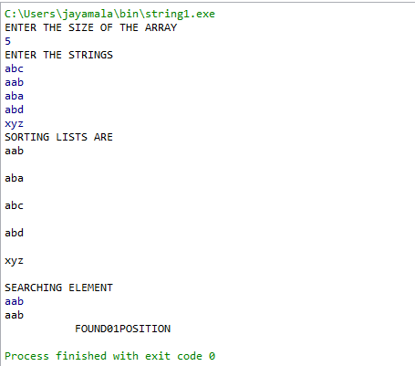

**\**

**SEQUENTIAL FILE FOR SORTING DATA**

IDENTIFICATION DIVISION.

PROGRAM-ID. Sequencefile.

ENVIRONMENT DIVISION.

INPUT-OUTPUT SECTION.

FILE-CONTROL.

SELECT StudentFile ASSIGN TO DISK.

DATA DIVISION.

FILE SECTION.

FD StudentFile

LABEL RECORDS ARE STANDARD

DATA RECORD IS StudentRec

VALUE OF FILE-ID IS "C:\Users\student\TEXT.txt".

01 StudentRec.

02 StudentId PIC 9(7).

02 StudentName.

03 Surname PIC X(8).

03 Initials PIC XX.

02 Department PIC X(5).

02 mailid PIC X(30).

WORKING-STORAGE SECTION.

77 N PIC 99.

77 C PIC 99 VALUE ZERO.

77 I PIC 99 VALUE ZERO.

77 sfname PIC X(3000).

77 slname PIC X(3000).

77 sname PIC X(6000).

77 sdept PIC X(3000).

77 smail PIC X(3000).

77 destr PIC X(9000).

77 fnd PIC X(5000).

77 rpl PIC X(5000).

77 ovrlap PIC 9 VALUE ZERO.

77 uname PIC X(30000).

77 len PIC 99 VALUE ZEROS.

PROCEDURE DIVISION.

Begin.

DISPLAY "Enter total number of records in first file:".

ACCEPT N.

OPEN OUTPUT StudentFile.

PERFORM GetStudentRecord N TIMES.

DISPLAY " ".

CLOSE StudentFile.

DISPLAY "Records are Succesfully Written".

PERFORM FindReplaceAll.

STOP RUN.

FRFile.

IF ovrlap=0

OPEN I-O StudentFile.

DISPLAY " ".

ADD 1 ovrlap GIVING ovrlap.

PERFORM PutStudentRecord.

GetStudentRecord.

DISPLAY "Enter Student Details:".

DISPLAY "First Name, Last Name, Department, MailID".

ACCEPT sfname.

ACCEPT slname.

*String Function - Concatenation

*sname = sfname + slname

STRING sfname DELIMITED BY SPACES

SPACE DELIMITED BY SIZE

INTO sname.

STRING sname DELIMITED BY SPACES

INTO sname.

MOVE sname TO StudentName OF StudentFile.

ACCEPT Department OF StudentFile.

ACCEPT mailid OF StudentFile.

WRITE StudentRec.

PutStudentRecord.

READ StudentFile RECORD AT END GO TO EndOperation.

PERFORM IntoAnotherFile.

GO TO PutStudentRecord.

IntoAnotherFile.

IF I<C

DISPLAY " ".

MOVE 0 to len.

MOVE mailid OF StudentFile TO smail.

*String Function - Find and Replace All

*String gmail will be replaced by ymail

*INSPECT smail REPLACING ALL 'gmail' BY 'ymail'.

MOVE smail TO mailid OF StudentFile.

MOVE StudentName OF StudentFile TO sname.

MOVE Department OF StudentFile TO sdept.

REWRITE StudentRec.

*String Function - Split

*String before @ will be stored in unmae

UNSTRING smail DELIMITED BY '@'

INTO uname

*String Function - Length

*Length of the Mail ID

INSPECT smail TALLYING len FOR CHARACTERS BEFORE INITIAL''.

DISPLAY "Name:" sname.

DISPLAY "Department:" sdept.

DISPLAY "Mail ID:" smail.

DISPLAY "UserName:" uname.

DISPLAY "Mail ID Length:" len.

DISPLAY " ".

ADD 1 I GIVING I.

EndOperation.

DISPLAY " ".

DISPLAY "Total No of Record in File:" N.

DISPLAY " ".

CLOSE StudentFile.

FindReplaceAll.

DISPLAY " ".

IF ovrlap=0

GO TO FRFile.

//tocopy

IDENTIFICATION DIVISION.

PROGRAM-ID. seq1.

ENVIRONMENT DIVISION.

INPUT-OUTPUT SECTION.

FILE-CONTROL.

SELECT INFILE ASSIGN TO DISK

ORGANIZATION IS LINE SEQUENTIAL.

SELECT OUTFILE ASSIGN TO DISK

ORGANIZATION IS LINE SEQUENTIAL.

DATA DIVISION.

FILE SECTION.

FD INFILE

LABEL RECORDS ARE STANDARD

VALUE OF FILE-ID IS "TEXT.txt".

01 INTEXT.

02 ITEXT PIC X(79).

FD OUTFILE

LABEL RECORDS ARE STANDARD

VALUE OF FILE-ID IS "OUTTEXT.txt".

01 OUTTEXT.

02 OTEXT PIC X(79).

WORKING-STORAGE SECTION.

77 EOF PIC 9 VALUE 0.

PROCEDURE DIVISION.

MAIN-PARA.

OPEN INPUT INFILE.

OPEN OUTPUT OUTFILE.

READ INFILE RECORD AT END MOVE 1 TO EOF.

PERFORM X-PARA UNTIL EOF = 1.

DISPLAY "SEE OUTTEXT.txt FILE FOR THE TEXT".

CLOSE INFILE OUTFILE.

STOP RUN.

X-PARA.

WRITE OUTTEXT FROM INTEXT.

READ INFILE RECORD AT END MOVE 1 TO EOF.

**OUTPUT :**

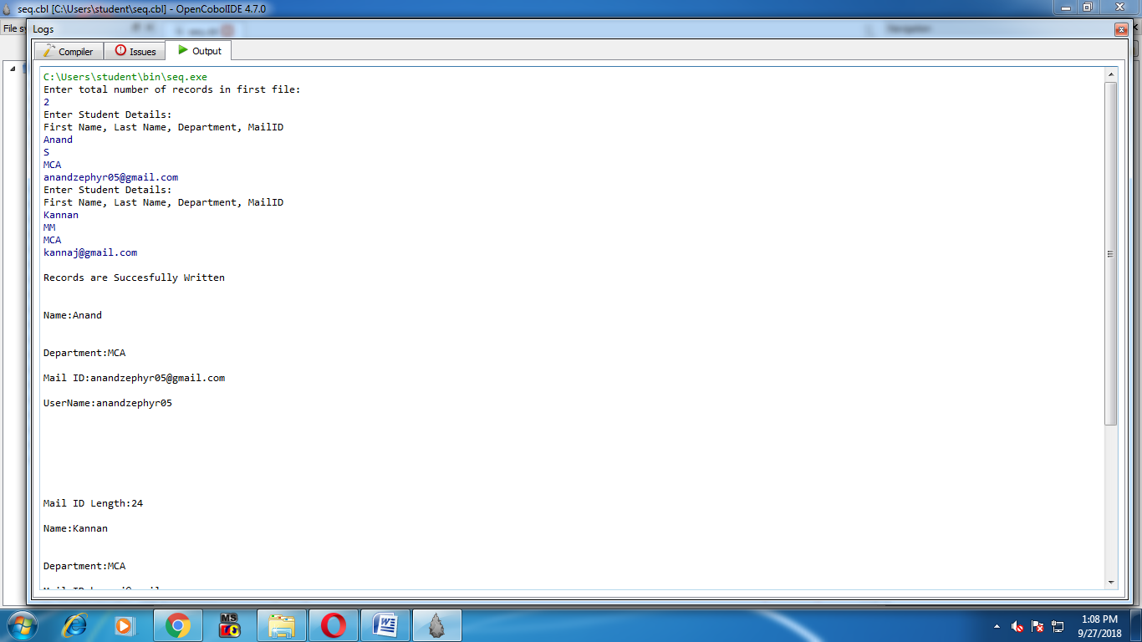

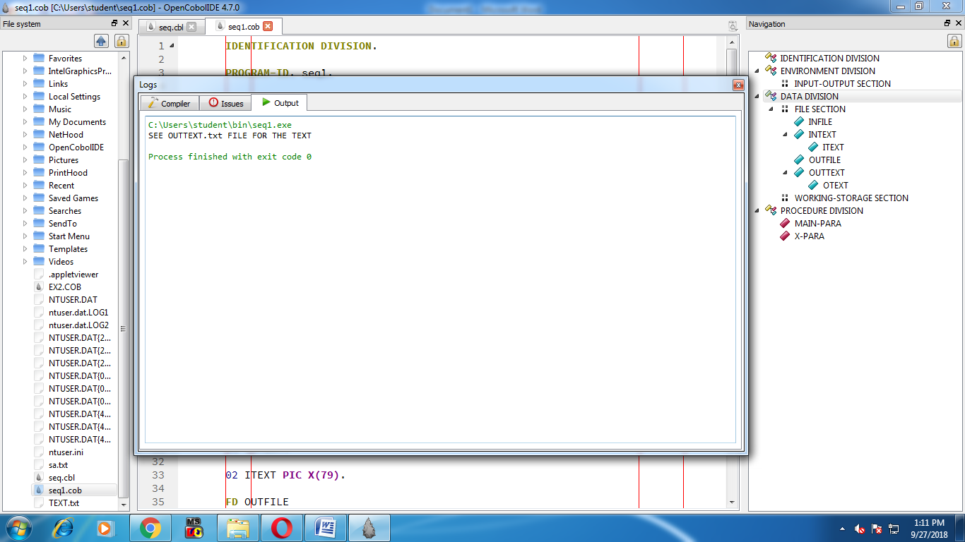

**INDEXED SEQUENTIAL FILE FOR SORTING DATA**

IDENTIFICATION DIVISION.

PROGRAM-ID. EX2.

AUTHOR."xxx"

DATE-WRITTEN."27/09/18".

DATE-COMPILED."27/09/18"

ENVIRONMENT DIVISION.

CONFIGURATION SECTION.

SOURCE-COMPUTER.M8.

OBJECT-COMPUTER.M8.

INPUT-OUTPUT SECTION.

FILE-CONTROL.

SELECT STUD1 ASSIGN TO DISK

ORGANIZATION IS SEQUENTIAL

ACCESS MODE IS SEQUENTIAL.

SELECT STUD2 ASSIGN TO DISK

ORGANIZATION IS SEQUENTIAL

ACCESS MODE IS SEQUENTIAL.

SELECT OUT ASSIGN TO DISK

ORGANIZATION IS SEQUENTIAL

ACCESS MODE IS SEQUENTIAL.

SELECT WORK ASSIGN TO DISK

ORGANIZATION IS SEQUENTIAL

ACCESS MODE IS SEQUENTIAL.

DATA DIVISION.

FILE SECTION.

FD STUD1

LABEL RECORDS ARE STANDARD

VALUE OF FILE-ID IS "STUD1.DAT".

01 STUD1-REC.

02 R-NO1 PIC 99.

02 NAME1 PIC X(10).

02 ATT1 PIC 99.

02 PER1 PIC 99.

02 OVERALL1 PIC 999.

FD STUD2

LABEL RECORDS ARE STANDARD

VALUE OF FILE-ID IS "STUD2.DAT".

01 STUD2-REC.

02 R-NO2 PIC 99.

02 NAME2 PIC X(10).

02 ATT2 PIC 99.

02 PER2 PIC 99.

02 OVERALL2 PIC 999.

FD OUT

LABEL RECORDS ARE STANDARD

VALUE OF FILE-ID IS "MERGE.DAT".

01 OUT-REC.

02 R-NO3 PIC 99.

02 NAME3 PIC X(10).

02 ATT3 PIC 99.

02 PER3 PIC 99.

02 OVERALL3 PIC 999.

SD WORK.

01 WORK-REC.

02 R-NO4 PIC 99.

02 NAME4 PIC X(10).

02 ATT4 PIC 99.

02 PER4 PIC 99.

02 OVERALL4 PIC 999.

WORKING-STORAGE SECTION.

77 N PIC X.

PROCEDURE DIVISION.

OPEN OUTPUT STUD1,STUD2.

PARA-1.

DISPLAY "---FOR FILE1---".

DISPLAY "Enter roll no".

ACCEPT R-NO1.

DISPLAY "enter name".

ACCEPT NAME1.

DISPLAY "Enter Mark1".

ACCEPT ATT1.

DISPLAY "Enter Mark2".

ACCEPT PER1.

COMPUTE OVERALL1=ATT1+PER1;

WRITE STUD1-REC.

DISPLAY "Do u want to continue... PRESS Y".

ACCEPT N.

IF N = "Y"

GO TO PARA-1.

PARA-2.

DISPLAY "---FOR FILE2---".

DISPLAY "Enter roll no".

ACCEPT R-NO2.

DISPLAY "Enter name".

ACCEPT NAME2.

DISPLAY "Enter Mark1".

ACCEPT ATT2.

DISPLAY "Enter Mark2".

ACCEPT PER2.

COMPUTE OVERALL2=ATT2+PER2;

WRITE STUD2-REC.

DISPLAY "TO CONTINUE...PRESS Y".

ACCEPT N.

IF N="Y"

GO TO PARA-2.

END-PARA.

CLOSE STUD1,STUD2.

MERGE-PARA.

MERGE WORK ON ASCENDING KEY R-NO4 USING STUD1,STUD2

GIVING OUT.

OPEN INPUT OUT.

DISPLAY "------------------------------------".

DISPLAY "ROLL NAME MARK1 MARK2 OVERALL".

DISPLAY "------------------------------------".

READ-PARA.

READ OUT AT END GO TO LAST-PARA CLOSE OUT.

DISPLAY R-NO3 " "NAME3" "ATT3" "PER3" "OVERALL3.

GO TO READ-PARA.

LAST-PARA.

STOP RUN.

**OUTPUT:**

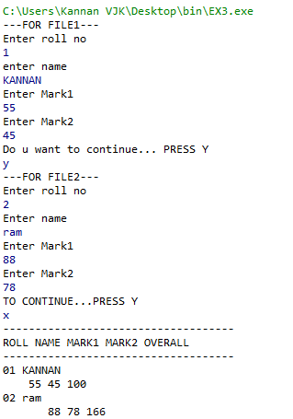

**DIRECT ACCESS FILE FOR SORTING DATA**

IDENTIFICATION DIVISION.

PROGRAM-ID. Ex4.

ENVIRONMENT DIVISION.

INPUT-OUTPUT SECTION.

FILE-CONTROL.

SELECT StudentFile ASSIGN TO DISK

ORGANIZATION IS RELATIVE.

DATA DIVISION.

FILE SECTION.

FD StudentFile

LABEL RECORDS ARE STANDARD

DATA RECORD IS StudentRec

VALUE OF FILE-ID IS "TEST1.txt".

01 StudentRec.

02 StudentId PIC 9(7).

02 StudentName.

03 Surname PIC X(8).

03 Initials PIC XX.

02 Department PIC X(5).

02 mailid PIC X(30).

02 mailid2 PIC X(30).

WORKING-STORAGE SECTION.

77 N PIC 99.

77 C PIC 99 VALUE ZERO.

77 I PIC 99 VALUE ZERO.

77 sfname PIC X(8).

77 slname PIC X(8).

77 sname PIC X(30).

77 sdept PIC X(3).

77 smail PIC X(30).

77 cop PIC X(30).

77 destr PIC X(90).

77 fnd PIC X(50).

77 rpl PIC X(50).

77 ovrlap PIC 9 VALUE ZERO.

77 uname PIC X(30).

77 len PIC 99 VALUE ZEROS.

01 st PIC X(1).

01 en PIC X(1).

PROCEDURE DIVISION.

Begin.

DISPLAY "Enter total number of records in first file:".

ACCEPT N.

OPEN OUTPUT StudentFile.

PERFORM GetStudentRecord N TIMES.

CLOSE StudentFile.

DISPLAY "Records are successfully written".

PERFORM FindReplaceAll.

Stop RUN.

FRFile.

IF ovrlap=0

OPEN I-O StudentFile.

DISPLAY " ".

ADD 1 ovrlap GIVING ovrlap.

PERFORM PutStudentRecord.

GetStudentRecord.

DISPLAY "Enter student details:".

DISPLAY "first name,last name,department,mailid".

ACCEPT sfname.

ACCEPT slname.

2

STRING sfname DELIMITED BY SPACES

' 'DELIMITED BY SIZE

INTO sname.

STRING sname DELIMITED BY SPACES

INTO sname.

MOVE sname TO StudentName OF StudentFile.

ACCEPT Department OF StudentFile.

ACCEPT mailid OF StudentFile.

WRITE StudentRec.

MOVE mailid to cop.

PutStudentRecord.

READ StudentFile RECORD AT END GO TO EndOperation.

PERFORM IntoAnotherFile.

GO TO PutStudentRecord.

IntoAnotherFile.

IF I<C

DISPLAY " ".

MOVE mailid OF StudentFile TO smail.

INSPECT smail REPLACING ALL 'gmail' BY 'ymail'.

MOVE smail TO mailid OF StudentFile.

MOVE StudentName OF StudentFile TO sname.

MOVE Department OF StudentFile TO sdept.

REWRITE StudentRec.

UNSTRING smail DELIMITED BY '@'

INTO uname

INSPECT smail TALLYING len FOR CHARACTERS BEFORE INITIAL ' '.

DISPLAY "First name : " sfname.

DISPLAY "Last name :"slname.

DISPLAY "Name(CONCATENAE):" sname.

DISPLAY "Department :" sdept.

DISPLAY "Mail-ID :" smail.

DISPLAY "Username :" uname.

DISPLAY "Mail ID Length :" len.

DISPLAY "Copied MAilid :" cop.

DISPLAY "repalced mailid string values".

ACCEPT st.

ACCEPT en.

DISPLAY "OLD STRING BEFORE REPLACING:" mailid.

INSPECT mailid REPLACING ALL st BY en.

DISPLAY "NEW STRING AFTER REPLACING :"mailid.

DISPLAY " ".

ADD 1 I GIVING I.

EndOperation.

DISPLAY " ".

DISPLAY "Total no of records in file:"N.

DISPLAY " ".

CLOSE StudentFile.

FindReplaceAll.

DISPLAY " ".

IF ovrlap=0

GO TO FRFile.

**OUTPUT:**

